Online Expert Lecture on “Alternative IC Engine Fuels”

Event Date: May 14th, 2022

Event Venue: SBBSU (Online)

Organizing unit/ agency/ collaborating agency: Deptt of EE, SBBSU

Number of students participated in such activities: 45

Summary of Report: (Objective, highlights and snapshots like images should be included)

Objectives:

- To familiarize students with several alternative fuels that can be burnt in IC engines to eliminate or significantly reduce CO₂ emissions into the atmosphere.
- To educate students about different types of fuels that could be employed, such as those based on turpentine or even glycerin, in order to keep IC engines as a viable mode of transportation.

Highlights:
- The EE department, Sant Baba Bhag Singh University (SBBSU), Jalandhar, organized an online expert lecture on “Alternative IC Engine Fuels” on May 14th, 2022.
- The resource person was Er. Palwinder Singh (Alumnus, EE, Batch 2016-20), Assistant Engineer, 33 MW Thermal Power Plant, Superior Food Grains Pvt. Ltd., Shamli, UP, INDIA
- A total of 45 students and 7 faculty members attended the expert lecture.
- The resource person discussed a variety of alternative fuels that can be used in internal combustion engines to reduce Carbon emissions in order to keep IC engines as a feasible means of transportation.
- The webinar was ended by vote of thanks by Er. Neha Kapila (Assistant Profesoor, Deptt of EE).

Snapshots:
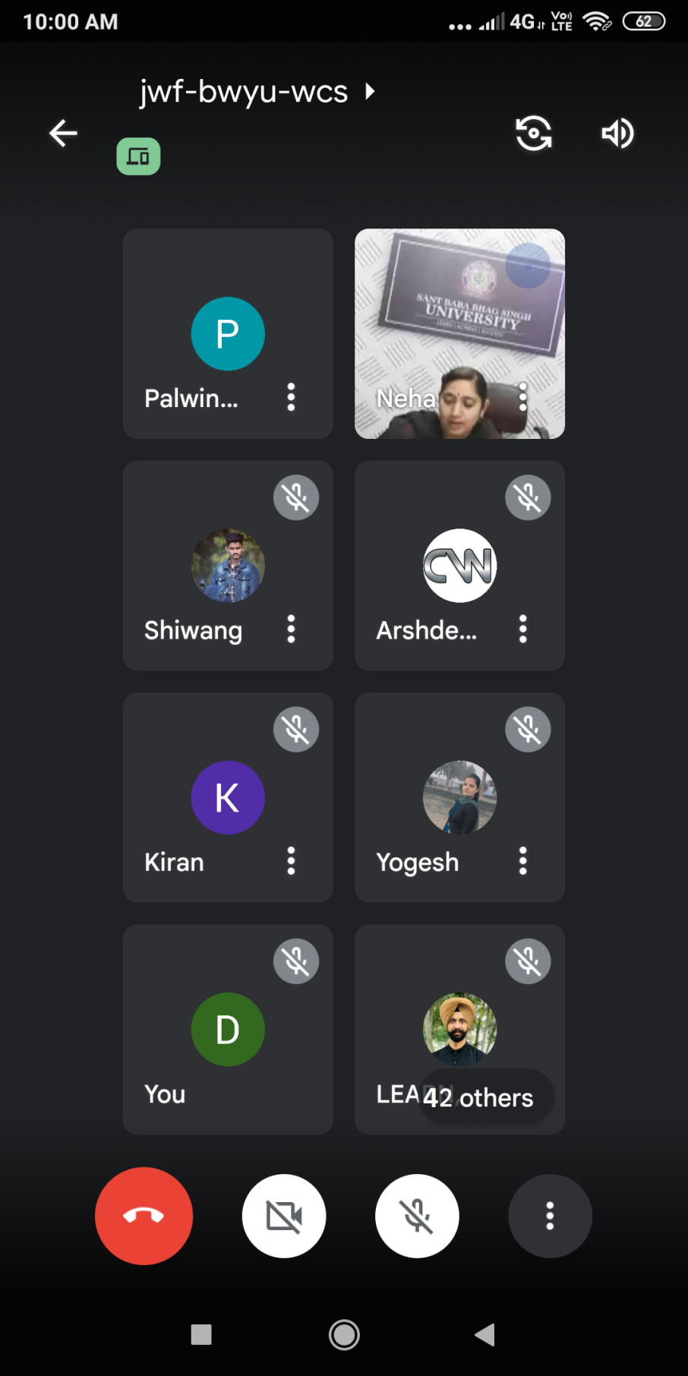
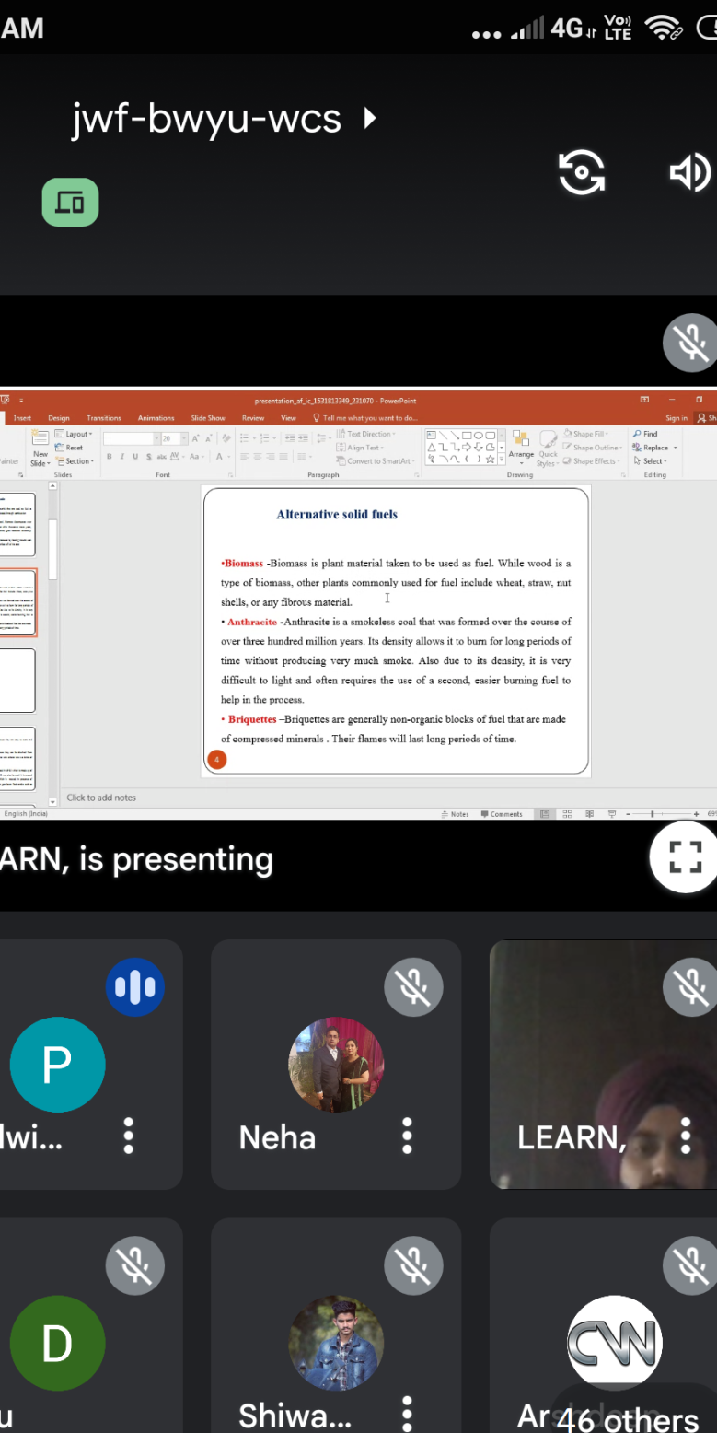
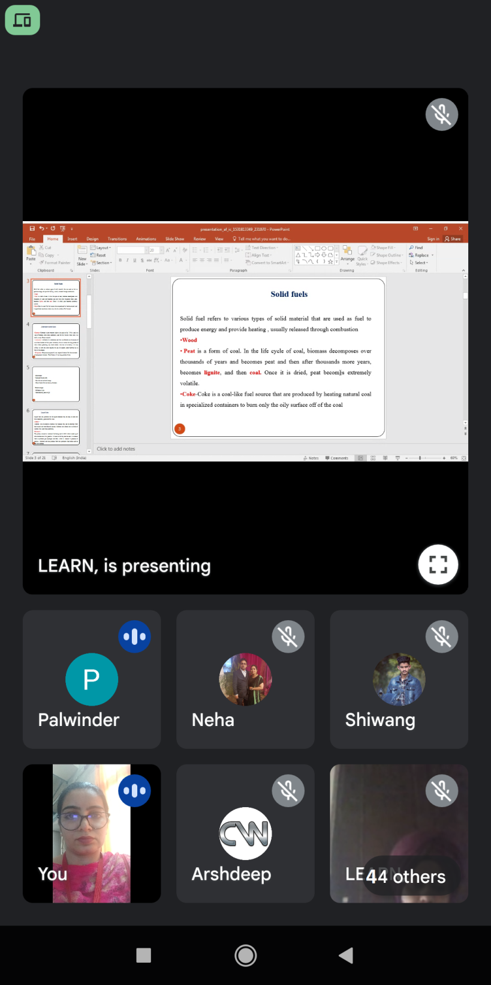

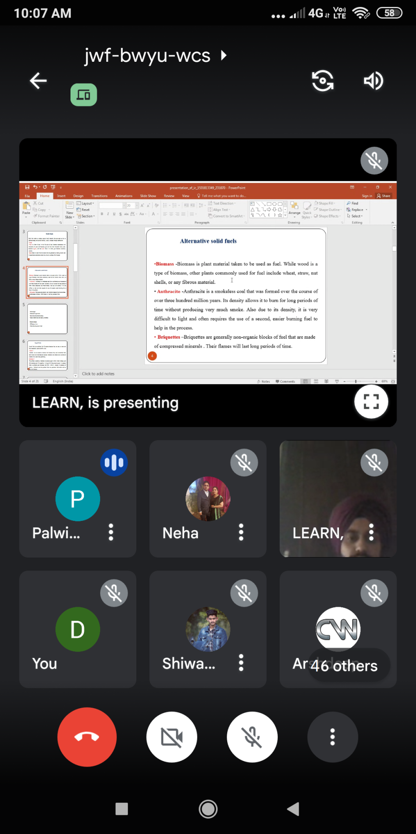
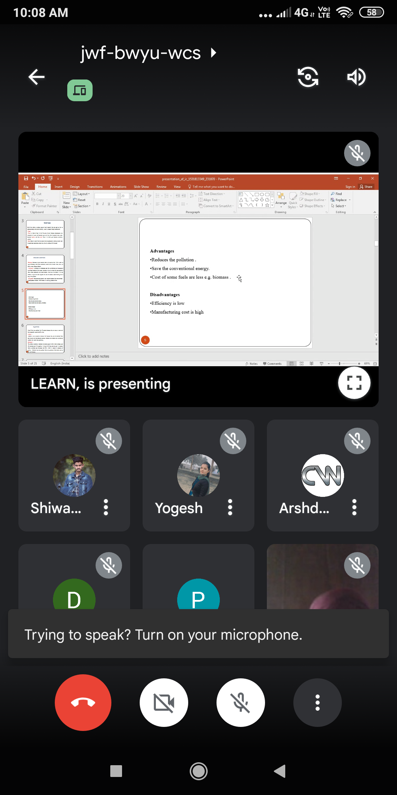

Thanks & Regards,
Dr. Gurmanik Kaur,
Associate Professor & Head, EE,
SBBSU, Jalandhar

